EPSRC Healthcare Impact Partnership for new blood clotting diagnostics and management

Background - the unmet healthcare need and its significance
Abnormal blood clot microstructure is a feature of arterial and venous thrombotic disorders which cause significant morbidity and mortality in Western society, with stroke being the third leading cause of death in the UK. Blood coagulation involves the development of a gel network of branching fibrin fibres - the primary microstructural component of the clot. Abnormal clot microstructures are characterised by denser fibrin networks, smaller pores and increased rigidity. Intra-clot diffusion is a rate limiting factor for the activity of the fibrin degradation enzyme plasmin and clots with abnormal microstructure can exhibit different susceptibility to fibrinolysis (breakdown). These features suggest that abnormal clot microstructure plays a pivotal role in thromboembolic (TE) disease and disorders including myocardial infarction, coronary artery disease, and venous thromboembolism, VTE [ ].
VTE involves important issues of patient safety, causing in excess of 25,000 potentially preventable deaths per annum within UK hospitals - five times the estimated number from hospital-acquired infection [1]. The oral anticoagulant warfarin is a widely used therapeutic tool in TE disease. At least 1.2 million people presently use warfarin in the UK. Standard coagulation tests have failed to relate hypercoagulability to abnormal clots in TE disease and correlation to clinical outcome has been unsatisfactory, with uncertain healthcare benefits [6,7]. Strikingly, recurrent thromboembolic events have been reported for some VTE patients who appear adequately anticoagulated by warfarin according to their International Normalised Ratio (INR) results [ ].
Improved detection and prediction of abnormal clot formation in pathologically and therapeutically modified blood, with the ability to screen for potential recurrence of embolic events, is a significant unmet healthcare need. We propose to meet this need by linking viscoelastic and spectral analysis of clot microstructure and exploiting it to provide clinicians with the ability to rigorously assess modified clotting outcomes based on data obtained in rapidly performed, near patient tests.

Previous work relevant to the HIP proposal. Our haemorheological studies (EP/C513037/1) led to the discovery that the fractal microstructure of incipient clots provides a new biomarker of modified clotting and a Healthy Index range for normal clotting [ , ]. That biomarker, the incipient clot’s fractal dimension, d_{f}, is obtained from a Gel Point analysis of blood (Sec. X). Its clinical potential is linked to the incipient clot’s role as a ‘template’ for the evolution of fully-formed (‘mature’) clot microstructure.
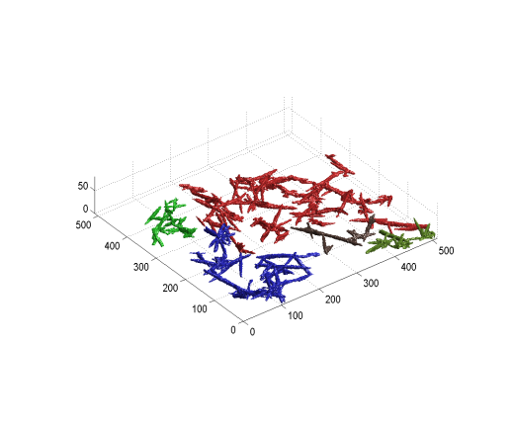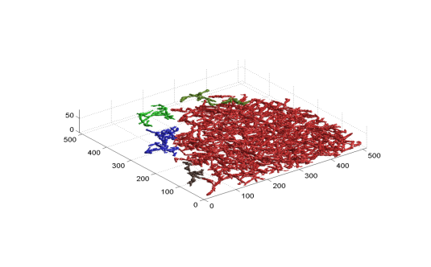
Figure.1. Fractal templates for fully-formed clots: Incipient fibrin clots formed at low (left) and high (right) thrombin concentration, respectively. Increases in d_{f} reflect large increases in fibrin mass - a feature associated with TE disease [ ].The network mass at d_{f} = 2.03 (right) is four-times greater than at d_{f} = 1.85 (left). d_{f} is a basis for predicting the internal connectivity of mature clot microstructure.

Under EP/G061882/1 we confirmed this templating role and discovered how d_{f} (incipient) is a predictor of clotting outcome [ ]. Specifically, d_{f} is a basis for predicting details of the internal connectivity of mature clot microstructure in terms of the ‘spectral’ dimension, d_{s}. Subtle changes in d_{f} can yield significantly altered mature clot microstructure with potentially serious outcomes e.g. d_{s} is a key determinant of intra-clot diffusion and hence the ability of tissue plasmin activator to activate plasminogen to fibrinolytic plasmin. The ability to detect and predict the development of such alterations in whole blood, at the earliest stage, has significant clinical potential. Incipient clot d_{f} can be obtained rheometrically within a few minutes of sample collection. Mature clots develop over 20+ minutes in healthy blood, and far longer in anticoagulated blood. The available therapeutic options informed by early detection and characterization of abnormal clot development are greatly enhanced.
VISION. Our work on early (incipient) stage templating of abnormal clot outcomes involved studying model fibrin-thrombin clots. If replicated in samples of pathologically- and therapeutically-modified blood, our findings would provide a basis for improved monitoring and prediction of abnormal clotting outcomes from incipient clot data which can be obtained in near-patient rheological tests, within minutes of sample collection. Testing this, and laying the technological foundations for its clinical exploitation are the principal aims of our Healthcare Impact Partnership.
2. Proposed work. Work on whole blood demands a different approach to that in which we used fluorescently-tagged fibrinogen to study fibrin clot assembly. Under EP/H008683/1 and EP/H024271/1 we developed identification/tracking techniques for fluorescent nanoparticles, FNPs, which produce stable optical markers from which cellular morphology and motion can be analysed. This approach emphasises recognition/tracking of discrete, binary-coded objects, rather than complex, multi-valued, grey scale image fields. Preliminary results (fig. 2) demonstrate the feasibility of using this approach to image the evolving blood clots fibrin network.

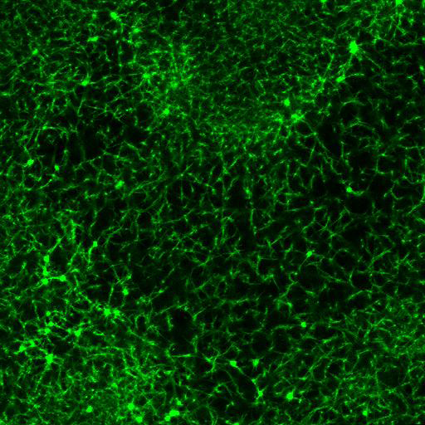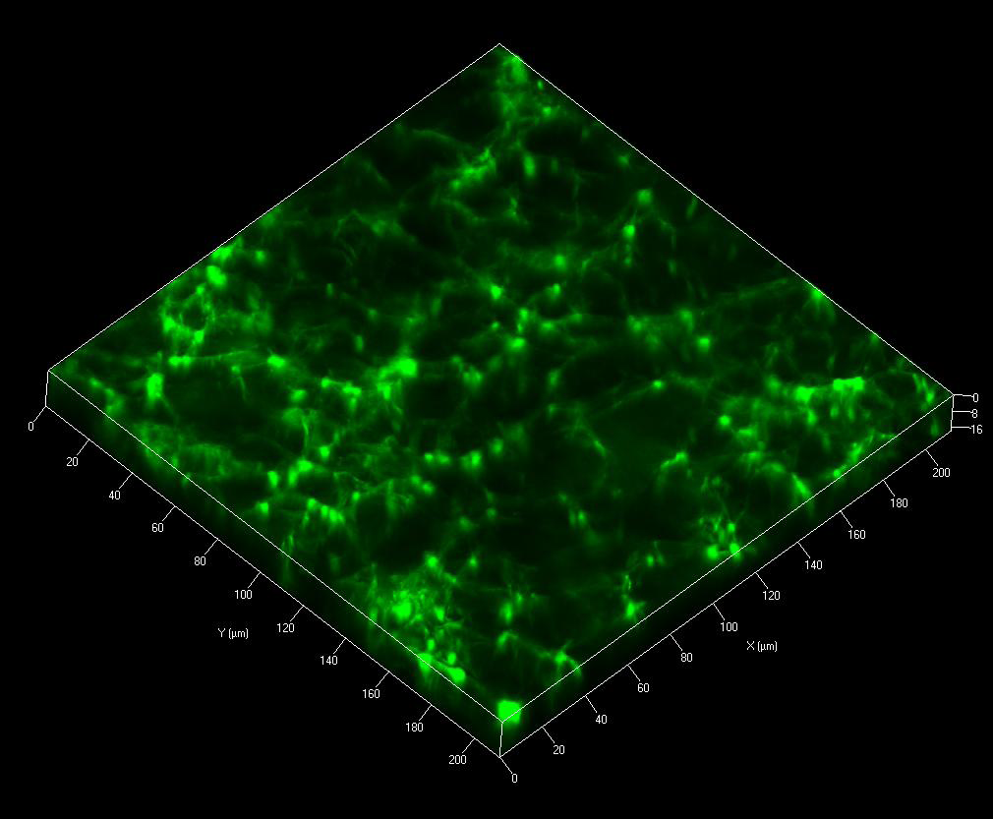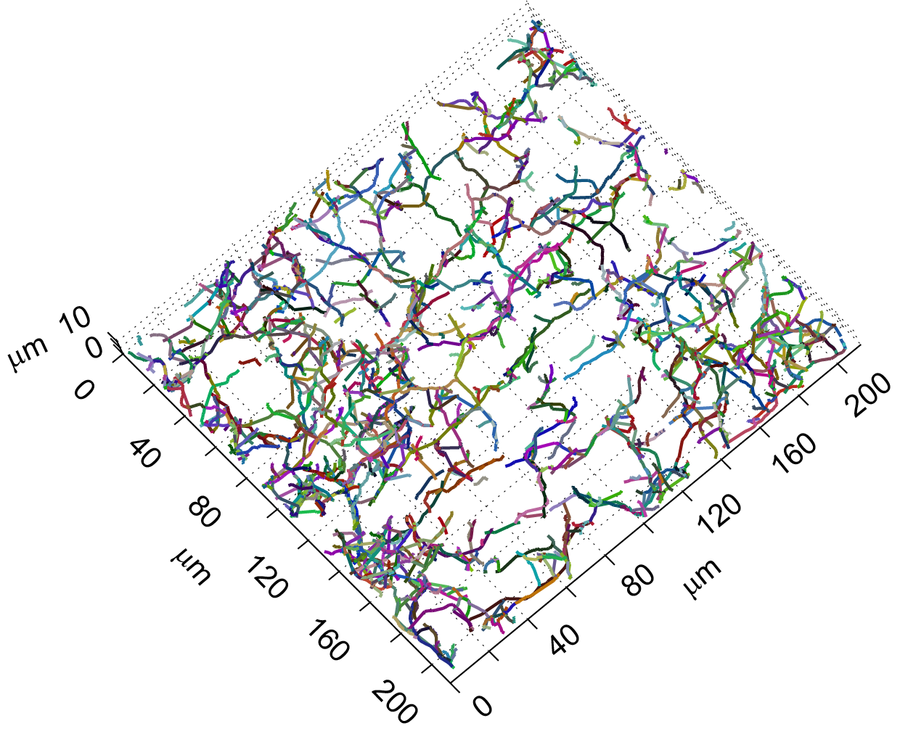
Figure 2. Proof of concept: Left: section of the fibrin network in a clot formed after a few minutes in whole healthy blood. Middle: z-stack. These unprocessed images are the first such of a forming clot in whole blood. Right: Binarized representation of the fibrin network within the z-stack; analysis of these binary representations allows the calculation of geometrical, fractal and viscoelastic properties of the clot as they develop and later lyse. Incorporation of the FNPs does not affect incipient clot ‘template’ microstructure.

PROPOSAL. The link between fractal template and clot outcome has never been studied in whole blood. We propose to do so in our HIP. The scientific basis for doing so is the analysis of FNP tracking to (i) quantify the evolution of fully-formed clot microstructures from their incipient ‘templates’; and
(ii) to characterise the evolution of clot viscoelasticity by particle tracking microrheology, PTM.
PTM exploits the thermally driven diffusive motion of particles to probe viscoelasticity (Sec. Xz). In small amplitude oscillatory shear (SAOS) the elastic and viscous components of the complex shear modulus (G'(w) and G’’(ω), respectively) scale as power-laws frequency w at the Gel Point GP [G’(ω) ~ G’’(ω) ~ ω^{α}]. At the GP, d_{f} is calculated from d_{f} = (d + 2)(2a – d)/2(a – d) where d is the space dimension [ ]. A knowledge of the time-dependent particle mean square displacement, MSD, allows G’(ω) and G’’(ω) to be determined by PTM measurements [ ]. A vital consideration is the relative scale of the particle(s) vis a vis microstructure. Our discovery that the incipient clot is a fractal object is significant in that they display structure which is replicated from those of the basic gel network units up to those of the bulk i.e. there is no single characteristic lengthscale [ ]. Our LSCM-PTM approach will exploit this fractal scaling to probe microstructural features representative of the whole clot network.
Our spectral analysis of clot microstructure is based on the concept that diffusion within fractal systems is characterized by the anomalous diffusion coefficient d_{w} which has been related to the ‘spectral’ dimension, d_{s} [ ]. Both d_{w} and d_{s} are sensitive to alterations of biological tissue microstructure [ ]. We have shown how d_{f} (incipient) can predict the internal connectivity of mature fibrin networks in terms of d_{s}. Higher or lower values of d_{s} characterize increases or decreases in network connectivity, respectively [ ]. Estimating d_{s} involves the analyzing the MSD of random walks on fibrin networks within 3d (x-y-z) reconstructions of LSCM data [ ].

The foregoing ideas are a basis for establishing new diagnostic and monitoring tools to address unmet healthcare needs in the following main areas.

(i) Improved monitoring of clotting responses to anticoagulant therapies. Present clotting tests often fail to detect rapid changes between hyper- and hypo-coagulable states. Many such tests lack standardisation and involve excessive test turnaround times which do not account for patho-physiological change, or on-going treatment. Rapid testing on whole blood is required for more accurate assessment of patho-physiological progression in terms of (i) coagulation abnormalities and (ii) early therapeutic targeting of abnormal clots. Moreover, there is a serious healthcare issue associated with VTE patients who appear adequately anticoagulated by warfarin (in terms of INR) but who suffer recurrence of thromboembolic events. The NISCHR HBRU has established that d_{f} is significantly elevated in such patients. Clot formation was studied in 142 patients in two groups, all anticoagulated using warfarin, all with comparable INR values, within the therapeutic range. The first group contained VTE patients: the second (non-VTE) contained patients with cardiac conditions. A sub-population of the VTE group had suffered a recurrent VTE event (r-VTE). A significant difference (p<0.001) in d_{f} was found between VTE, r-VTE and non-VTE patients. All other haematological tests failed to distinguish between VTE and non-VTE patients.
These findings have significant healthcare potential. To capitalize on them we need to establish that we can link the formation of abnormal clot templates to pernicious alterations of mature clot microstructure in such patients. We aim to establish a basis both for the effective screening of such patients. In addition we seek to address improved monitoring and prediction of their responses to alternative therapeutic regimes in terms of modified clotting outcomes. Our foundation for this is a study which established that d_{f} is a significant predictor of anti-FXa at concentrations of heparin within the therapeutic range (0.3 - 0.7 IU/ml by heparin anti-FXa analysis) and higher (up to 0.8 IU/ml).

(ii) Improved predictions of clot lysis in response to treatments. Clots with altered fibrin microstructure (hence permeability) exhibit different susceptibility to fibrinolysis. The effect of anticoagulants such as heparin increases clot permeability. Intra-clot diffusion - the key parameter - is related to d_{s} [ ]. Our ability to quantify the internal connectivity of the mature clot’s fibrin network in terms of d_{s} and to relate it to d_{f} (incipient) is a potentially transformative key to developing a predictive capability which will allow clinicians to use rapidly acquired data (d_{f}) from near patient tests to assess clotting outcomes in terms of altered fibrinolytic characteristics. No such capability exists at present.

In summary, we have at hand a new basis for using data from rapid point of care tests to inform clinicians on clotting outcomes in vital aspects of abnormal blood clot formation. To capitalize on this we have planned a structured, systematic programme involving the exploitation of basic science and its development, through to validation and application in clinical settings, within our HIP.

PROPOSED WORK PROGRAMME
WP 1. LSCM-PTM studies of modified fibrin clot network microstructure. Model (fibrin-thrombin) clots will be used to refine FNP tracking and analysis for haemorheological applications in LSCM-PTM. In fibrin clots d_{f} is dependent on thrombin concentration [ ]. Many pro-thrombotic conditions stimulate rapid clotting and increased clot ‘density’ whereas anticoagulation prolongs clot formation, yielding less ‘compact’ clots [ ]. Rheological measurements (SAOS) quantify these features in terms of d_{f} and incipient clot formation time, T_{GP} , at the Gel Point, GP.
The first key goal of WP1 will be using LSCM-PTM to identify the establishment of the power-law scaling of G’(w) and G’’(w) at the GP and to verify the results in terms of G’(w), G’’(w), T_{GP} and d_{f} using conventional rheometry (SAOS). The sequence of experiments will be as follows. Human fibrinogen at concentrations ranging from healthy to pathophysiological (x-y mg/ml) will be polymerized using different levels of thrombin to produce a range of d_{f} spanning values in anticoagulated blood (1.55 < d_{f} < 1.74) and pathologically modified blood (1.74 < d_{f} < 2.0). ‘Baseline’ model clots, formed using fluorescently tagged fibrinogen, will be characterized in terms of (i) G’(w), G’’(w), T_{GP} by SAOS and (ii) their incipient and mature microstructures (d_{f} and d_{s}) using LSCM. Replicate systems will be formed (using non-fluorescent fibrinogen) and will be loaded with FNPs at different concentrations, sizes and modified particle surface charge (neutral and carboxylated, -‘ve surface) to assess the efficacy of particle type for clot labelling. (By building on experience with nanoparticle labelling of primary blood cells [], we will assess the benefits of analysing cellular fluorescence, in addition to the fibrin network). The parameters G’(w), G’’(w), T_{GP}, d_{f} and d_{s} will be obtained on these systems using SAOS and LSCM-PTM.
The second key goal of WP1 will be verifying that combined microstructural and viscoelastic measurements by LSCM-PTM provide the same relationship between d_{f} (incipient) and d_{s} (mature) as reported by separate rheometric (SAOS) and LSCM measurements [ ]. In seeking to correlate the high content image data characterizing mature clot microstructure to our rheometric biomarker (obtained on the incipient clot) we will adopt a Machine Learning approach based on image classifiers. Fibrin clots formed over ranges of d_{f} will be used as learning sets. We intend to use this approach to automate analysis and classification of clotting outcomes based on imaging and to correlate them to the fractal characteristics of the incipient clot templates. Subsequently we will use this approach to analyse and classify samples from VTE and r-VTE patients as the basis of a rapid screening capability (see WP3, below). To this end, biological imaging tools (ImageJ and CellProfiler) will enable us to extract 100s of image features relating to the fractal microstructure of the clot networks. The use of image feature extraction to identify cell phenotypes and explore cellular processes is widely used []. We will employ these methods to identify patient disease states (or phenotypes) from the fibrin network data. Selection techniques and machine learning algorithms will enhance our ability to predict abnormal clotting outcomes from different template microstructures.
The third key goal of WP1 will be to guide the optimization of nanoparticle loading. We seek to reduce their concentration to the minimum required for imaging. Preliminary work (on healthy blood) shows that their incorporation does not affect clot template microstructure, the values of d_{f} (and T_{GP}) obtained by Gel Point analysis in the presence of FNPs (d_{f} = 1.75 + 0.08) being commensurate with the Healthy Index for unadulterated whole blood [ ].

WP 2. LSCM-PTM studies of healthy and therapeutically modified blood clot microstructure.
This WP is intended to validate that the incipient clot’s templating role is replicated in therapeutically modified blood. Firstly this involves validating the haemorheological application of LSCM-PTM by confirming Healthy Index values for G’, G’’, T_{GP} and d_{f} from FTMS [ ]. Subsequently we will apply LSCM-PTM alongside SAOS to whole healthy blood containing unfractionated heparin at concentrations chosen with reference to ACCP consensus regarding treatment of VTE [ ]. Aliquots from the bulk sample used for LSCM-PTM will be used for full blood count analysis.
The key anticipated outcomes from this WP will be (i) confirmation that d_{f} (incipient) can be used to predict clotting outcome in terms of d_{s} (mature) and (ii) that this can be related directly to alterations in the fibrinolytic characteristics of mature clots. To do so, samples will be tested using fibrinolytic marker analysis (t-PA-PAI 1 complex ELISA assay, and D-Dimer analysis). We will augment this with NMR pulsed field gradient (PGF) measurements of intra-clot diffusion to provide estimates of d_{w} and d_{s} using a 500 MHz Bruker NMR spectrometer in our haemorheology laboratory.
Our concept of quantifying the internal connectivity of the mature clot’s fibrin network in terms of d_{s} and relating it to d_{f} (incipient) is the key to developing a new predictive capability which will allow clinicians to use rapidly acquired data (d_{f}) from near patient tests to assess clotting outcomes in terms of altered fibrinolytic characteristics. These include identifying the potential development of pernicious clots with abnormally high resistance to breakdown and dispersal. No such capability exists at present in terms of making these assessments on the basis of data obtained in rapid, near patient tests.
WP 3. LSCM-PTM studies of modified clot microstructure in warfarinised VTE and non-VTE patient blood. We plan to build on the results of a study at the NISCHR HBRU in which a significant difference (p<0.001) in d_{f} was found between VTE, r-VTE (recurrent) and non-VTE patients, all of whom had comparable INR values in the therapeutic range. To capitalize on the significant healthcare potential of these findings we wish to use LSCM-PTM to establish that we can link the formation of abnormal clot templates (abnormally high d_{f} ) to pernicious alterations of mature clot microstructure in such patients. Our aim is to establish a basis both for their effective screening, and for monitoring and predicting responses to alternative therapeutic regimes in terms of modified clotting outcomes. As in WP2, we will seek confirmation that d_{f} (incipient) can be used to predict clotting outcome in terms of d_{s} (mature) and that this can be related directly to alterations in the fibrinolytic characteristics of the mature clots (using fibrinolytic markers, see WP 2).

Blood Sampling and Data Collection. Blood will be taken from volunteers within VTE, r-VTE (recurrent) and non-VTE patient groups identified by the NISCHR HBRU. Sampling and Data Collection will be undertaken with full ethical approval from the local regulatory ethics committee and will involve patient information and fully informed written consent. The study will follow STARD guidelines [ ]. Blood will be taken slowly and atraumatically from the antecubital vein via a 21-gauge butterfly line into a 20ml syringe. Patient information and data will conform to the 1998 data protection act (sec. 3.2, and Annex 3) and the Caldicot guidelines. Data will be entered anonymously into a coded database within secure Trust facilities. All patients will conform to ethical standards, will receive an information sheet and will sign a consent form. This work involves blood sampling under NHS Trust guidelines using standard phlebotomy techniques. Patient recruitment will be on a voluntary basis. Healthy samples will be obtained from a group subject to strict exclusion criteria [ ].

In our work clotting is initiated by venipuncture/sampling and the FNPs are added to the sample as it experiences further contact and activation at the measuring surfaces of the rheometer/LSCM slide surfaces. The role of the FNPs is to contact the nascent fibrin template during the incipient clot’s establishment – not to modify it. We will seek to verify this in therapeutically and pathologically modified blood by conducting the tests described above. Our preliminary results suggest this is achievable.

Brief Track Record
Paul Rees in currently the Professor of Nanotechnology at the College of Engineering at Swansea University, Visiting Professor at the Broad Institute of Harvard and MIT and a Senior Affiliate of the Methodist Hospital Research Academy. He has just returned from a sabbatical at the Image Platform at the Broad Institute (funded by an EPSRC International Collaboration Sabbatical Grant, EP/J00619X/1) which specializes in the use of profiling drug screens, gene interventions and cell phenotypes using fluorescence microscope images. Current research interests include the investigation of metrologies for assessing the uptake and effect of nanoparticles on cells (EP/H008683/1) and the development of tools for synthetic biology (EP/L011573/1).

Further, our development (under EP/G061882/1) of the world’s longest out-of-plane hollow silicon microneedles, with industry partner SPTS, will be exploited for blood sampling – a key aspect of translation to the clinical environment. Incorporating these with our electro-stimulated drug delivery platforms [7] could lead to targeted delivery of therapeutics.
Arrays of hollow “tapered tip” MNs with lumen diameters of 100 to 150 μm and up to 700 μm in length have been fabricated (Fig. ?). Skin penetration testing revealed that modified needle densities were required for enhanced skin penetration, while the penetration force could be reduced using sharper tipped microneedles.
We will develop novel, beveled tip microneedle arrays for facile skin penetration. Microneedle lengths of up to 1.4 mm will be fabricated, with skin insertion depths estimated at 1.2 mm – deep enough to extract blood from the dermis but with minimal pain. Application of MNs to the skin surface results in superficial penetration of the outer skin barrier layer, the stratum corneum (SC), permitting targeted extraction of blood without impinging significantly on the nerves that reside in the deeper regions of skin. Extraction from the skin using MNs is therefore a refined and painless technique, which does not rely upon excessive force or major damage to the skin architecture.
SPTS (Industry manufacturing partner) are able to achieve longer MNs than other manufacturers, using their Bosch dry etch processes in their specially developed Pegasus deep Reactive Ion Etch (RIE) tool. Only using such a production tool can MNs of 1 mm or greater be fabricated on a production scale. The Pegasus tool is able to etch up to 1 mm in just an hour on a full 200 mm diameter silicon wafer.
Novel paired bevelled MNs will be fabricated using a multi-step photolithography, hard-mask and 2-step Bosch etch process, to achieve both high aspect ratio lumens and large open etch load areas between MNs. Photo-mask sets will be designed for fabrication of novel bevelled MNs (Fig. 3) using bore diameters (75-150 µm), MN wall thickness (50-100 µm) and MN pitch (75-1400 µm) and lengths (200-1400 µm). The bevelled MN tips will be fabricated using an innovative metal hard mask and spray coating processes (Fig. 3a-c) (the basis of a current patent application) and subsequent KOH wet etch step to produce the bevelled tips. The bevelled tip is etched using KOH, to develop a V-grooved feature in the silicon wafer (Fig 3b). This process uses differential etch rates of the (100) and (111) orientation silicon crystal planes in KOH, to reveal the (111) angled groove planes on the wafer surface. These planes will act as the bevelled needle tips. The bevelled structure is then ready for the bore and shaft etching deep silicon etch process, to be performed at SPTS (Fig. 3c and 3d). A resist spray coating process is required to coat the photoresist into the deep grooves created by the KOH wet etch. The spray system forms millions of micrometer sized photoresist droplets which are able to evenly coat the angled groove structures – impossible using a conventional spin coating system. Spray coating techniques also yield lower resist consumption compared to conventional spin coating techniques – enabling lower manufacturing costs.
(f)

A further related impact (from EP/I00193X/1) is an integrated sensor, microfluidics and packaging technology which will offer HIP partner companies a route to scale-up and eventual manufacture of point-of-care technologies.
Microneedles will be integrated with microchannels etched into a silicon wafer and bonded to the microneedle wafer. An integrated commercial micropump will be used to pump blood onto the analysis chip. All exposed surfaces will be coated in ….. to avoid any coagulation prior to blood entering the SAW sensor analysis chip.
The hollow MNs may also be linked with electro-stimulated drug delivery platforms, for targeted delivery of therapeutics, such as anticoagulants.

Exploiting advances in MEMS (Micro Electro-Mechanical Systems) technology and using novel etch processes will permit SU & SPTS to develop an engineering solution for the manufacture of several different hollow MN designs. Manufacturing will be translated to full wafer volume by SPTS.
SPTS are keen to exploit their world leading plasma etch technology for the rapidly developing bioMEMS market, taking a market lead.

1. Report to the Chief Medical Officer, Department of Health (2007) from the expert working group on the prevention of VTE in hosptialised patients. Estimates suggest 60,000 preventable deaths annually in the UK.

Objectives 4000char

- To undertake linked experimental and theoretical research involving a new application of nanotechnology to imaging, allied to viscoelastic and fractal analysis of blood clot microstructure and mechanical properties. This work address the clinically vital issue of abnormal blood clot formation, from the incipient clot ‘template’, to the fully-formed clot and its eventual breakdown.
- Abnormalities in these aspects of clot properties are linked to significant health risks. There is a pressing need for improved techniques to assess and predict clot abnormalities but present approaches have limited clinical utility in terms of informing responses to ongoing treatment or disease progression. Our objective is to meet that need based on information acquired within a few minutes in near-patient haemorheological tests on small (< 0.5 ml) samples of whole blood.
- In terms of healthcare focus our principal objective, at the outset, is abnormal clot formation in NHS patients undergoing warfarin anticoagulation therapy following venous thromboembolism (VTE). Specifically, we plan to target VTE patients who experience recurrence of abnormal clot formation despite appearing adequately anticoagulated in terms of their standard (INR) test results. Repeated instances of deep vein thrombosis and pulmonary embolism in such patients represent both a serious healthcare issue and a financially significant challenge to the NHS. Our work to date has detected abnormal incipient clot formation in such patients. Our objective is now to use that as a basis for responding to a clinically pressing need for improved monitoring, assessment and prediction of fully-formed clot abnormalities in these and other patients. To do so we need to exploit our recent discovery of the microstructural templating role of incipient fibrin-thrombin clots by applying it to study clot assembly in samples of pathologically and therapeutically modified blood. This will be supplemented by rheometric and NMR pulsed field gradient diffusion studies of model (fibrin-thrombin) clots.

- Our principal technical objectives are as follows. We will apply our recently reported combination of viscoelastic and spectral analysis of clot microstructure to the results of whole blood imaging based on the recording of targeted nanoparticle fluorescence (we reported our advances in the latter area in Nature Nanotechnology). Our quantification of clot abnormality will be based on the following related fractal parameters: Df (the fractal dimension), Ds (the spectral dimension) and Dw (the anomalous diffusion parameter). We will use our imaging technique in conjunction with shear wave propagation to analyse the evolution of the mechanical (viscoelastic) properties underlying haemostatic functionality. We plan to establish, for the first time, their relation to the microstructural basis of clot assembly.

- The overarching objective of our Healthcare Impact Partnership will be to provide the framework for collaboration between (i) experts in nanotechnological aspects of devices, imaging and analysis of complex biosystems; (ii) an industrial partner with expertise in haemorheological devices; and (iii) the NHS-based Haemostasis Biomedical Research Unit (HBRU) at ABMU NHS Trust Hospital Morriston Swansea. The HBRU, with its track record of haemorheological biomarker validation in care pathways, provides the clinically-facing focus for our studies and their translation. Our industrial partner brings expertise in digital signal processing for rheometry. Ultimately we foresee that this expertise will underpin technologies for near-patient tests within clinical environments including treatment rooms, wards and theatres.

Impact Summary 4000

- Who will benefit from this research?

The research involves the development of new techniques for improving the monitoring, assessment and prediction of abnormal blood clot formation in therapeutically and pathologically modified blood. The principal beneficiaries will therefore be patients (in the UK these will mainly be NHS patients), particularly those suffering from diseases which involve abnormal clot formation. These include patients suffering from thromboembolic disease (which causes significant morbidity and mortality in Western society), with stroke being the third leading cause of death in the UK. In addition, the research will directly benefit some 1 million NHS outpatients who require monitoring of oral anticoagulant therapy (OAT). Correlation of present standard clotting tests (e.g. INR) to clinical outcome has been unsatisfactory, with uncertain healthcare benefits. In particular the research will benefit those patients receiving warfarin OAT as a result of venous thromboembolism who suffer recurrence of deep vein thrombosis (DVT) and/or pulmonary embolism (PE) despite appearing adequately anticoagulated in terms of their standard (INR) test results. Repeated instances of DVT and PE in such patients represent a serious healthcare issue and are a financially significant challenge to the NHS.

More widely, the beneficiaries will include patients in whom abnormal blood clot formation requires improved monitoring of responses to anticoagulant/antiplatelet therapies (including aspirin); and those patients who require improved predictions of clot lysis in response to drug treatments; and patients who require improved dose assessments of these treatments.

Clinicians will also be beneficiaries of the research in terms of being equipped with new tools/techniques for assessing and predicting abnormal clot formation. Such techniques are urgently needed e.g. NICE guidelines (2010) require all 1.3M annual UK hospital admissions to be screened for clotting abnormalities but standard coagulation tests have failed to relate hypercoagulability to abnormal clots in thromboembolic disease due to insensitivity and poor reproducibility.

Companies in the medical device technologies sector will also benefit from the research. Significant commercial opportunities exist for the production of commercially available forms of new tests for clotting abnormalities, both within hospital (near patient) settings and more widely as the basis for point of care testing in GP surgeries, clinics or, eventually, within the homes of outpatients. The opportunities are substantial: the global market for monitoring and screening anticoagulated patients is estimated at over $2.25billion, growing at 5% annually (STFC). The opportunities are global due to demographic change and the increasing incidence of disease related clotting abnormalities linked to the acquisition of westernised diets.

- How will they benefit from this research?

In addition to the obvious ways in which patients would benefit from improved tests and hence better treatments, a principal benefit would be to their clinicians who would enjoy more reliable, timely information regarding responses to ongoing treatment or disease progression (better information, better care). An ability to screen patients who are non-responsive to warfarin and who develop abnormal clots would benefit the NHS by alerting clinicians to warfarinised VTE patient non-responsiveness, thereby allowing alternative treatments to be sought; and by reducing the financial costs of the hospital admissions associated with recurrence of DVT/PE. Companies able to provide new tests to target such patients would benefit from a recurrent source of income based on the sale of disposable test consumables. Ultimately, by making such tests compatible with operation in non-hospital settings (GP surgeries, clinics or homes), patients would benefit in terms of improved quality of life.

Summary (simple terms) 4000

We propose to establish a Healthcare Impact Partnership for research which is stimulated by an unmet clinical need for improved monitoring and prediction of abnormal clotting responses to therapy or disease. Thromboembolic disease and associated blood clotting abnormalities cause significant morbidity and mortality in Western society, with stroke being the third-leading cause of death in the UK. Clotting abnormalities are responsible for thousands of preventable deaths annually inside UK hospitals and increasing numbers of NHS outpatients require monitoring of oral anticoagulant therapy (e.g. warfarin). But correlation of standard clotting tests to clinical outcome has been unsatisfactory, with uncertain healthcare benefits and limited clinical utility in terms of informing responses to ongoing treatment or disease progression.

We wish to overcome these shortcomings by exploiting our advances in nanotechnology and clot detection. They provide the basis of a new way of monitoring, assessing and predicting the key microstructural and mechanical properties of fully-formed clots, based on image information acquired within a few minutes in near-patient tests on small samples of blood. The fully-formed clot’s microstructure determines its mechanical strength (hence its ability to prevent bleeding) and its resistance to breakdown and dispersal by the body. Abnormalities in these properties are linked to significant health risks.

Our discovery of the fractal microstructure of incipient (‘infant’) clots and its role in templating fully-formed (‘adult’) clots provides the basis of our proposal. We have established its feasibility through advanced imaging and analysis of model (fibrin-thrombin) clots. We now need to do this in therapeutically and pathologically modified blood. But our previous imaging techniques are not suitable for blood and we plan a new approach. Our work on nanoparticle fluorescence has established advanced identification/tracking techniques and we have implemented them to study biological cells. We plan to translate these approaches to analyse abnormal microstructure development in blood clots. The concept is based on interrogating nanoscale moving light displays (clusters of light), formed by fluorescent nanoparticles loaded into blood samples. An exciting aspect involves analysing clot deformation in response to stress. The light arrays provide a binary map of points delimiting clot structure and reporting deformation. We anticipate that this concept will provide a ‘world-first’ in yielding linked microstructural and mechanical properties of evolving clots, in the same measurement.

The improved monitoring, assessment and prediction capabilities arising from this work will underpin (i) improved monitoring of clotting responses to anticoagulant and/or antiplatelet (e.g. aspirin) therapies; (ii) improved predictions of clot breakdown in response to therapy; (iii) improved dose response assessments of these treatments, and (iv) a basis for abnormal clot screening in patients who, while taking warfarin, suffer recurrent deep vein thrombosis or pulmonary embolism while appearing adequately anticoagulated in terms of present tests (INR).
Our Healthcare Impact Partnership will provide the framework for collaboration between (i) experts in nanotechnological aspects of devices, imaging and analysis of biosystems; (ii) an industrial partner with expertise in medical device control and analysis; and (iii) the Haemostasis Biomedical Research Unit (HBRU) at ABMU NHS Trust Hospital Morriston Swansea. The HBRU, with its expert clinical scientists and NHS Consultant colleagues, provides the clinically-facing focus for our studies, and their translation. Our industrial partner brings expertise in digital signal processing for test devices. Ultimately we foresee that this expertise will underpin the development of technologies for near-patient tests both inside and outside hospital care settings.

“The fractal dimension....can be used as a biomarker for hemostasis, enabling the effects of disease and theraputic manipulation to be monitored in a novel and informative way not otherwise available using conventional clinical technology” Expert Comment in Blood (2010) on Evans et al [x].
Our discovery was the basis for establishing the £1.5M NISCHR Haemostasis Biomarker Research Unit (HBRU) at ABMU NHS Trust Hospital Swansea. The HBRU is a Project Partner in the HIP.
Liu Y, Guy OJ, et al. “An electric-field responsive microsystem for controllable miniaturised drug delivery applications”. Sensors and Actuators B: Chemical 175 (2012) 100.

